Threads and Processes
User Threads
_ Thread management done by user-level threads library
_ Examples
- POSIX Pthreads
- Mach C-threads
- Solaris threads
Synchronization
_ Background
_ The Critical-Section Problem
_ Synchronization Hardware
_ Semaphores
_ Classical Problems of Synchronization
_ Critical Regions
_ Monitors
_ Synchronization in Solaris 2 & Windows 2000
Race Condition
_ Race condition: The situation where several processes
access – and manipulate shared data concurrently. The
final value of the shared data depends upon which
process finishes last.
_ To prevent race conditions, concurrent processes must
be synchronized.
The Critical-Section Problem
_ n processes all competing to use some shared data
_ Each process has a code segment, called critical section,
in which the shared data is accessed.
_ Problem – ensure that when one process is executing in
its critical section, no other process is allowed to execute
in its critical section.
Solution to Critical-Section Problem
1. Mutual Exclusion. If process Pi is executing in its critical
section, then no other processes can be executing in their
critical sections.
2. Progress. If no process is executing in its critical section and
there exist some processes that wish to enter their critical
section, then the selection of the processes that will enter the
critical section next cannot be postponed indefinitely.
3. Bounded Waiting. A bound must exist on the number of times
that other processes are allowed to enter their critical sections
after a process has made a request to enter its critical section
and before that request is granted.
_ Assume that each process executes at a nonzero speed
_ No assumption concerning relative speed of the n processes.
Synchronization Hardware
_ Test and modify the content of a word atomically
.
boolean TestAndSet(boolean &target) {
boolean rv = target;
tqrget = true;
return rv;
}
_ Sometimes called ‘TSL’ instruction
_ Designed for multiple processors
_ TSL on one processor will lock out other processors
The Deadlock Problem
􀂄 A set of blocked processes each holding a resource and
waiting to acquire a resource held by another process in
the set.
􀂄 Example
􀀩 System has 2 tape drives.
􀀩 P1 and P2 each hold one tape drive and each needs another
one.
Deadlock Characterization
􀂄 Mutual exclusion: only one process at a time can use a
resource.
􀂄 Hold and wait: a process holding at least one resource
is waiting to acquire additional resources held by other
processes.
􀂄 No preemption: a resource can be released only
voluntarily by the process holding it, after that process
has completed its task.
􀂄 Circular wait: there exists a set {P0, P1, …, P0} of waiting
processes such that P0 is waiting for a resource that is
held by P1, P1 is waiting for a resource that is held by
P2, …, Pn–1 is waiting for a resource that is held by
Pn, and P0 is waiting for a resource that is held by P0.
Resource Allocation Graph With A Deadlock
Deadlock Prevention
􀂄 Mutual Exclusion – not required for sharable resources;
must hold for nonsharable resources.
􀂄 Hold and Wait – must guarantee that whenever a
process requests a resource, it does not hold any other
resources.
􀀩 Require process to request and be allocated all its
resources before it begins execution, or allow process to
request resources only when the process has none.
􀀩 Low resource utilization; starvation possible.
Sharing Memory
Effective Access Time
■ Associative Lookup = ∑ time unit
■ Assume memory cycle time is 1 microsecond
■ Hit ratio – percentage of times that a page number is found in the
associative registers; ratio related to number of associative registers
■ Hit ratio = ⟨
■ Effective Access Time (EAT)
EAT = (1 + ∑) ⟨ + (2 + ∑)(1 – a)
= 2 + ∑ – α
Paging Hardware With TLB
Two-Level Page-Table Scheme
Two-Level Paging Example
■ A logical address (on 32-bit machine with 1K page size) is divided into:
● a page number consisting of 22 bits
● a page offset consisting of 10 bits
■ Since the page table is paged, the page number is further divided into:
● a 12-bit page number
● a 10-bit page offset
■ Thus, a logical address is as follows:
where pi is an index into the outer page table, and p2 is the displacement within
the page of the outer page table
//DIAGRAM HerE
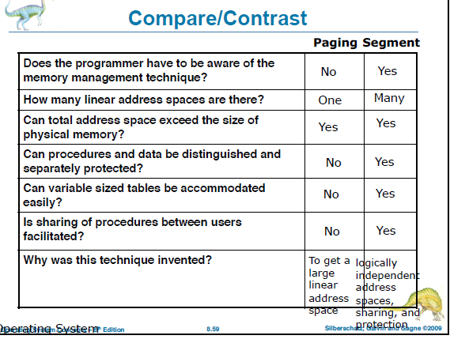
FileSystem + IO
I/O Hardware
■ Incredible variety of I/O devices
■ Common concepts
☞ Port
☞ Bus (daisy chain or shared direct access)
☞ Controller (host adapter)
■ I/O instructions control devices
■ Devices have addresses, used by
☞ Direct I/O instructions
☞ Memory-mapped I/O
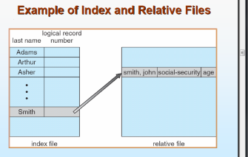
Linked Allocation
Each file is a linked list of disk blocks: blocks may be scattered anywhere on the disk.
Simple –need only starting address
Free-space management system –no waste of space
No random access
Mapping LA/512 – Q
|
R
Block to be accessed is the Qth block in the linked chain of blocks representing the file.Displacement into block = R + 1File-allocation table (FAT) –disk-space allocation used by MS-DOS and OS/2.
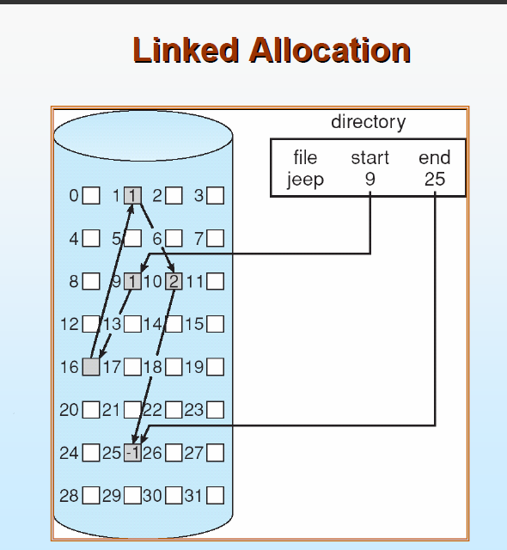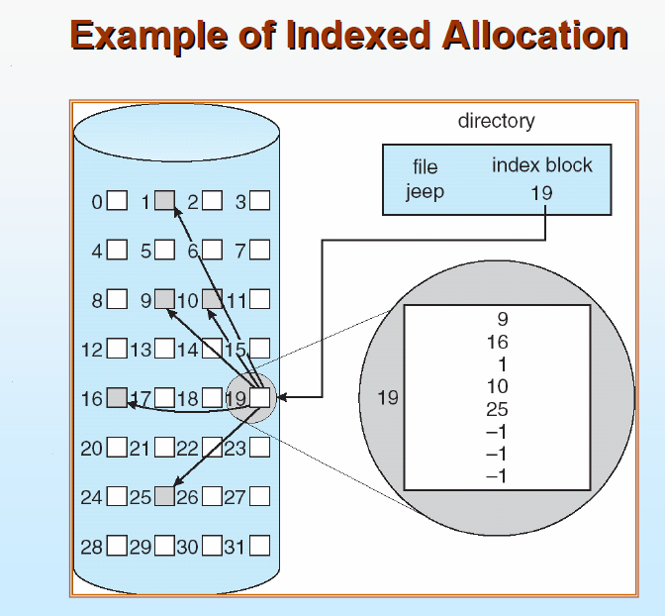
Indexed Allocation
􀂄Brings all pointers together into the index block.
􀂄Logical view. 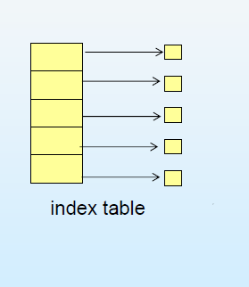
Need index table
􀂄Random access
􀂄Dynamic access without external fragmentation, but have overhead of index block.
􀂄Mapping from logical to physical in a file of maximum size of 256K words and block size of 512 words. We need only 1 block for index table.LA/512 -> Q
|
R
Q = displacement into index table
R = displacement into block
Mapping from logical to physical in a file of unbounded length (block size of 512 words).
􀂄Linked scheme –Link blocks of index table (no limit on size).
LA / (512 x 511) -> Q1
|
R1
Q1= block of index table
R1is used as follows:
R1/ 512 -> Q2
|
R2
Q2= displacement into block of index table
R2displacement into block of file:
Two-level index (maximum file size is 512^3)
LA / (512 x 512) -> Q1
|
R1
Q1= displacement into outer-index
R1is used as follows:
R1/ 512 -> Q2
|
R2
Q2= displacement into block of index table
R2displacement into block of file:
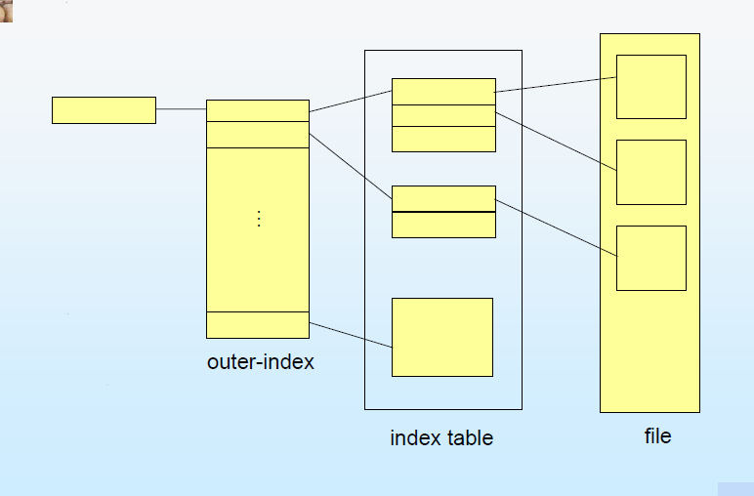
- Distributed system is collection of loosely coupled processors interconnected by a communications network
Processors variously called nodes, computers, machines, hosts
  - Site is location of the processor
- Reasons for distributed systems
  - Resource sharing
    - sharing and printing files at remote sites
    - processing information in a distributed database
    - using remote specialized hardware devices
  - Computation speedup – load sharing
  - Reliability – detect and recover from site failure, function transfer, reintegrate failed site
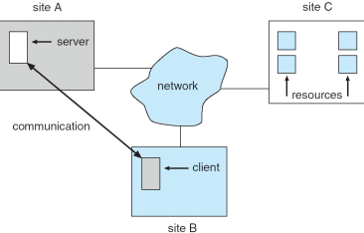
  - Communication – message passing

